Korea Advanced Institute of Science and Technology

School of Electrical Engineering

***EE735 Computer Vision Fall 2018***

**Report**

**Programming Assignment 1**

**Depth from Focus with Your Mobile Phone**

Student’s Name: Dinh Vu

Student’s ID: 20184187

1. **Step 1: Image Alignment**

For each dataset, the last image is chosen to be the reference frame such as image 24 in dataset 1 balls and image 31 in dataset 2 keyboard. The Speeded Up Robust Features (SURF) algorithm is chosen to extract features between the reference frame and the current frame. In this step, the Image Alignment Toolbox [1] is used for implementation.

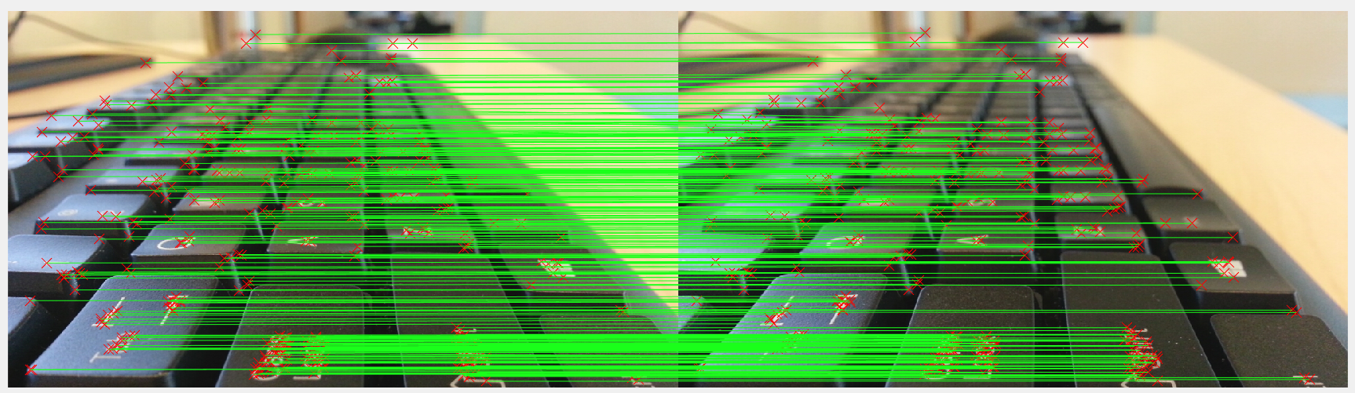

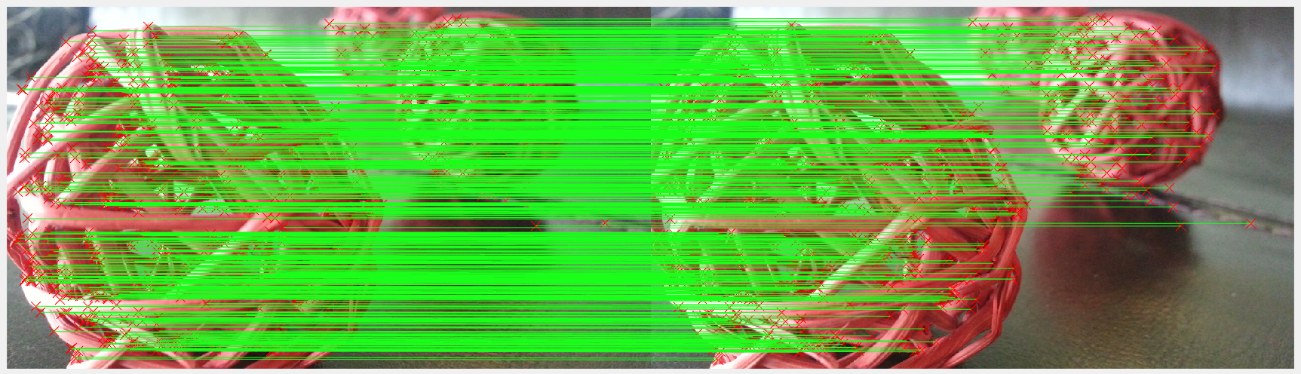

**Figure 1.1.** Image Alignment using SURF algorithm

The experiment shows that the error after alignment always less than the error before alignment.

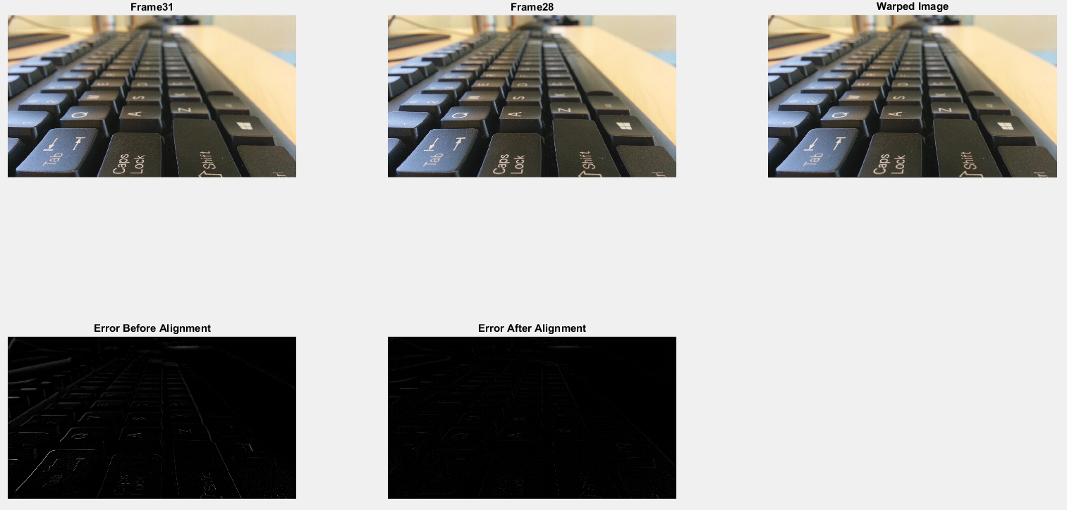

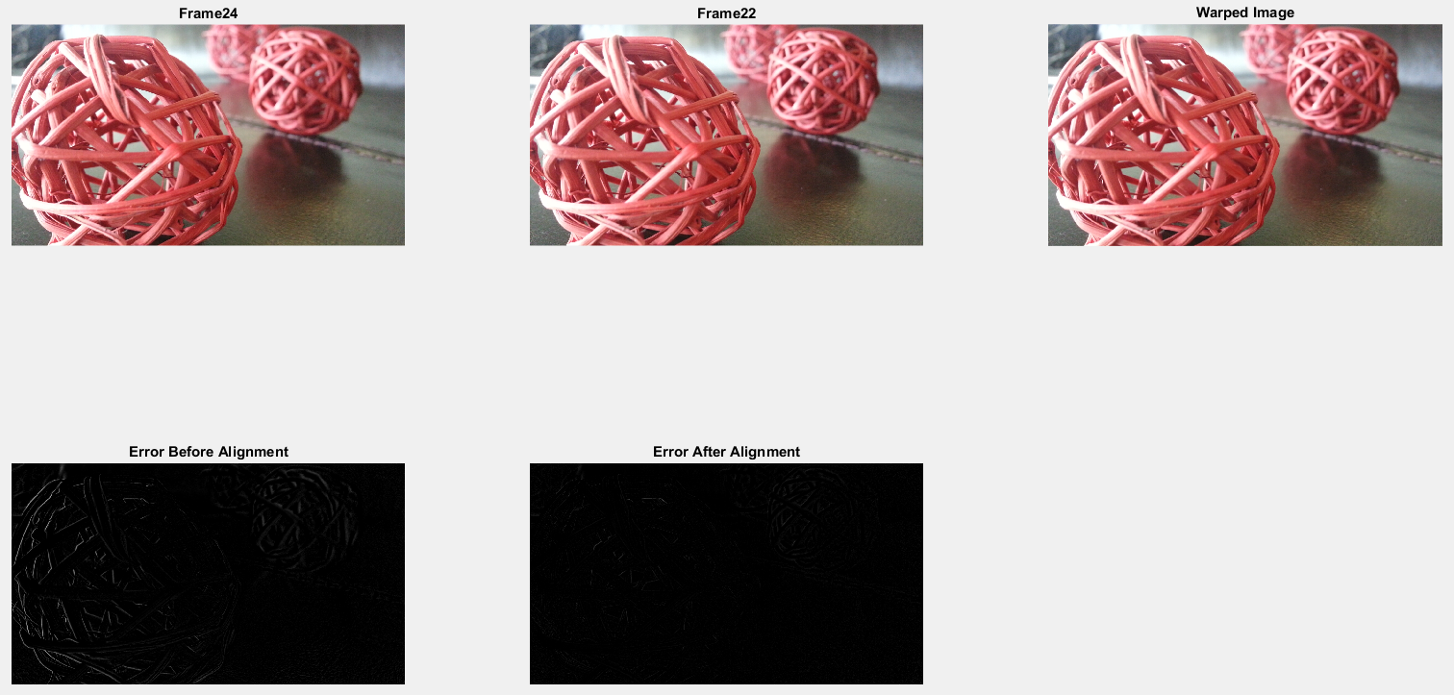

**Figure 1.2.** The error before and after alignment

1. **Step 2: Focus Measure**

After step 1, there are 25 warped images for dataset 1 or 32 warped images for dataset 2. The sharpness of pixel values in each image can be calculated by convolution between the intensity image and the Optical Transfer Function (OTF) [2].

$$i_{n}\left(x,y\right)=I_{n}\left(x,y\right)*OTF\left(x,y\right)$$

Where:

* $n$ is the index of the warped image
* $I_{n}$ is the intensity of the warped image $n$
* $\left(x,y\right)$ is the coordinates of the pixel in the spatial domain

Therefore, in the frequency domain, the convolution became the multiplication. The real part of the multiplication between the spectrum of the intensity image and the Fourier transform of OTF.

$$i_{n}\left(x,y\right)=Re\left\{F^{-1}\left[F\left[I\left(x,y\right)\right]×OTF\left(k_{x},k_{y}\right)\right]\right\}$$

Each warped image is transformed into the frequency domain by 2-D Fast Fourier Transform then the low frequency components are shift to the center of the image.

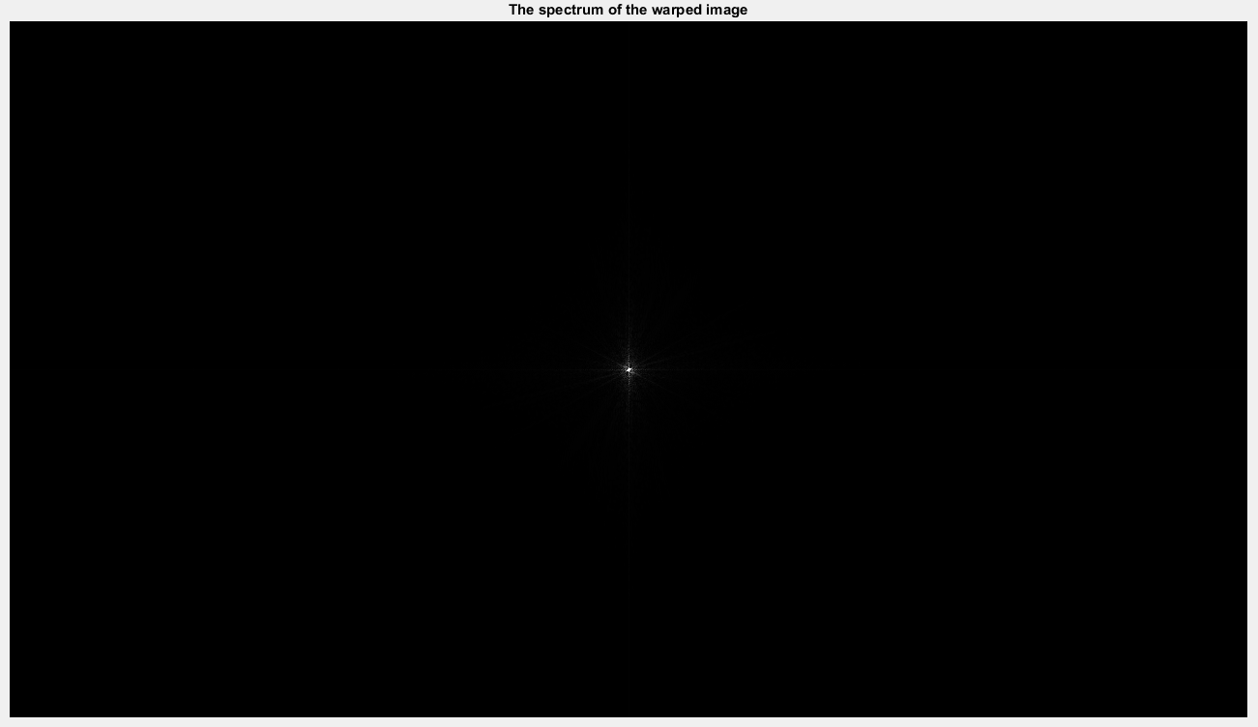

**Figure 2.1.** The spectrum of the warped image

In the frequency domain, OTF can be determined by the below formular.

$$OTF\left(k_{x},k_{y}\right)=exp\left[-σ_{1}\left(k_{x}^{2}+k_{y}^{2}\right)\right]-exp\left[-σ_{2}\left(k_{x}^{2}+k_{y}^{2}\right)\right]$$

Where:

* $k_{x}$, $k_{y}$ are the spatial frequency components
* $σ_{1}$, $σ_{2}$ define band-pass and their values are set by the experiments. In my experiments, $σ_{1}={10}^{-4}$ and $σ_{2}={10}^{-3}$.

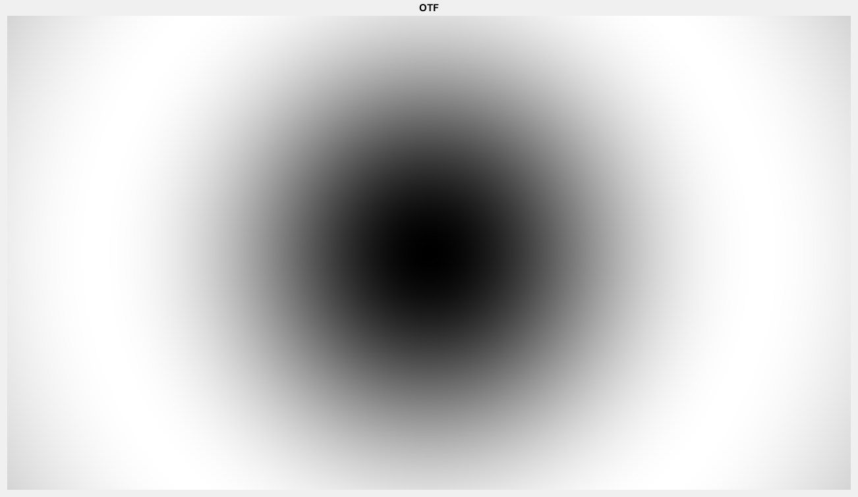

**Figure 2.2.** The spectrum of the OTF filter

The OTF filter remove the low and very high frequencies. After the warped image is filtered by the OTF, the result image is convoluted with the 3×3 window to sharp the edge.

$$FM\left(:,:,n\right)=i_{n}*\left[\begin{matrix}1 & 1 & 1 \\ 1 & 1 & 1 \\ 1 & 1 & 1\end{matrix}\right]$$

Where $FM\left(:,:,n\right)$ is the optical focus measure of the image $n$.

The initial focus map is created by labeling each pixel to image index following the maximum focus measure. It means that the number of labels equal to the number of images in the dataset.

$$\left[M_{p}\left(i,j\right),M_{f}\left(i,j\right)\right]=max\left\{FM\left(i,j,n\right)\right\}$$

Where:

* $\left(i,j\right)$ is the coordinates of the pixel at spatial domain
* $n$ is the index of the frame
* $M_{p}$ is a 2-D matrix, having the same size of the image, contains the best focus value (maximum value) for each pixel
* $M_{f}$ is a 2-D matrix, having the same size of the image, consists the index of the frame which give the best focus value at pixel $\left(i,j\right)$

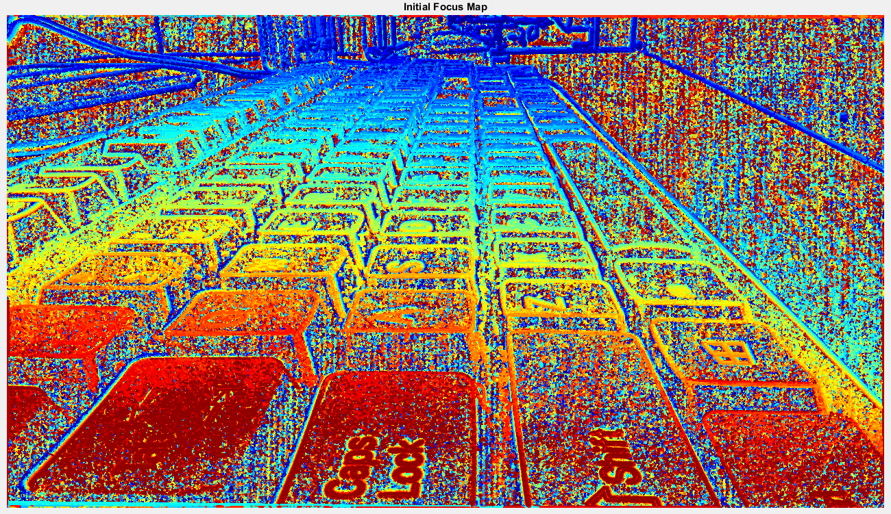

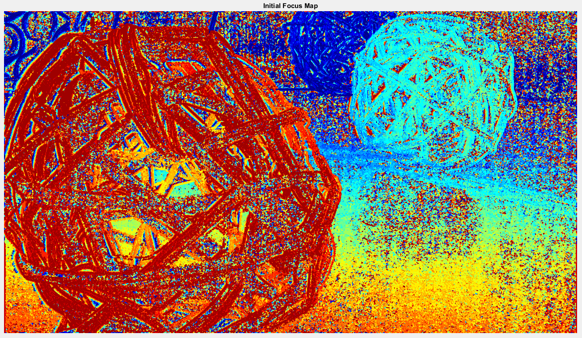

**Figure 2.3.** The initial focus map

1. **Step 3: Graph-cuts**

It is noticeable to see that in the initial focus map, there are many pixels are noise and labeled wrong. So, in the step 3, the label of all pixels are interpolated from their neighbor and the smoothness by the graph-cuts optimization in [3]. The authors of [3] provided the gco-v3.0 library [4] which can operate the min-cut/max-flow algorithm. In order to use the gco-v3.0 library, the matrices, presenting the data cost, smoothness cost and neighboring relation, have to be defined.

Data cost is the penalty of re-labeling the pixel. The label of a pixel is hard to be changed when the data cost of the pixel is low especially if the data cost equals to 0 the label of this pixel is unchanged, otherwise the label of a pixel is easily to be changed when its data cost is set to high. The data cost is determined by minimum of two L1 loss and a threshold. One L1 loss is between the optical focus measure of pixels by considering all the frames and the sharpness (maximum value) of pixels, other is between the restoration intensity of initial focus map and index of the warped frame. The threshold prevents the probability of re-labeling is too high.

$$DC\left(i,j,n\right)=min\left\{\left|FM\left(i,j,n\right)-M_{p}\left(i,j,n\right)\right|,\left|M_{f}\left(i,j,n\right)-n\right|,max_dc\right\}$$

Where:

* $\left(i,j,n\right)$ is the pixel of the frame $k$ at the spatial coordinate $\left(i,j\right)$
* $DC$ is the data cost of the pixel at $\left(i,j,n\right)$
* $max_dc$ is the upper bound of data cost, set to 128 by experiments

Smoothness cost constrain the continuous labeled segmentation which means that the neighboring pixels tend to have the same label.

$$SC\left(i,j\right)=min\left\{\left|i-j\right|,max_smoothness\right\}$$

Where:

* $\left(i,j\right)$ is the coordinates of the pixel
* $SC$ is the smoothness cost matrix.
* $max_smoothness$ is the maximum of smoothness cost, set to 15 by experiments

Neighbor matrix is a sparse matrix which defines the relation between pixels. A pixel is connected with 4 neighboring pixels at up, down, left, right directions with 1.

It is easy to see in the graph-cuts images that the regions in the boundary are miss classified due to the warping in the alignment process.

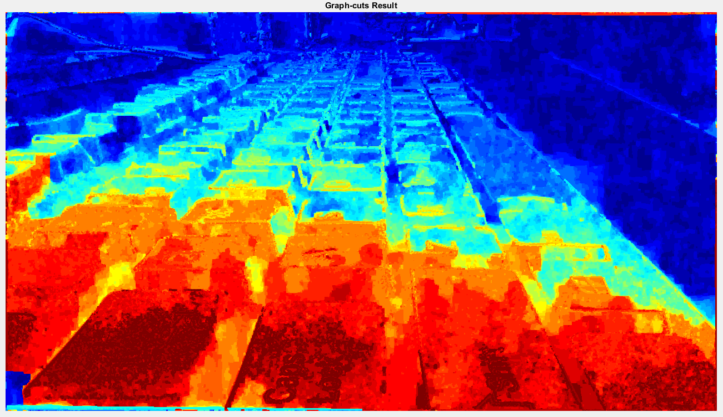

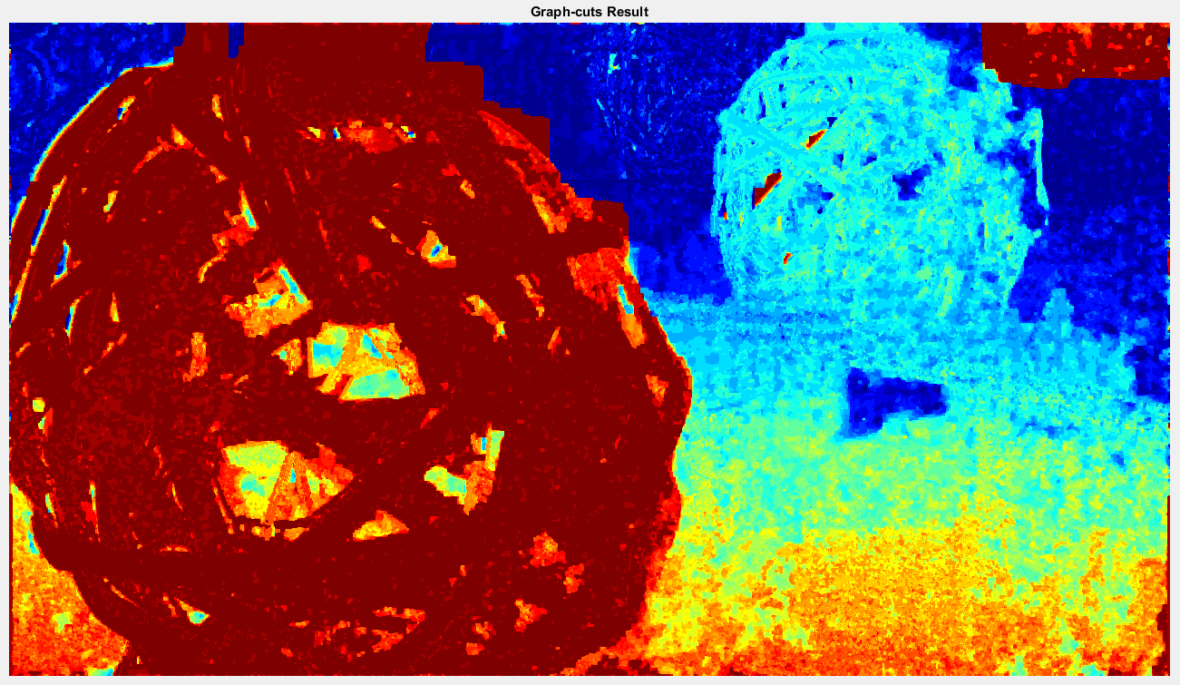

**Figure 3.1.** The graph-cuts result

1. **Step 4: All in Focus**

In the graph-cuts result, each pixel has its own integer label from 0 to number of image minus 1. Assume that pixel $\left(i,j\right)$ has label $n$. The RGB components of pixel $\left(i,j\right)$ in the warped image index $n$ are copied to the position $\left(i,j\right)$ of the all-in-focus image.

$$AIF\left(i,j\right)=I_{n}\left(i,j\right) if L\left(i,j\right)=n$$

Where $AIF$ is the all-in-focus image and $L$ is the graph-cuts image.

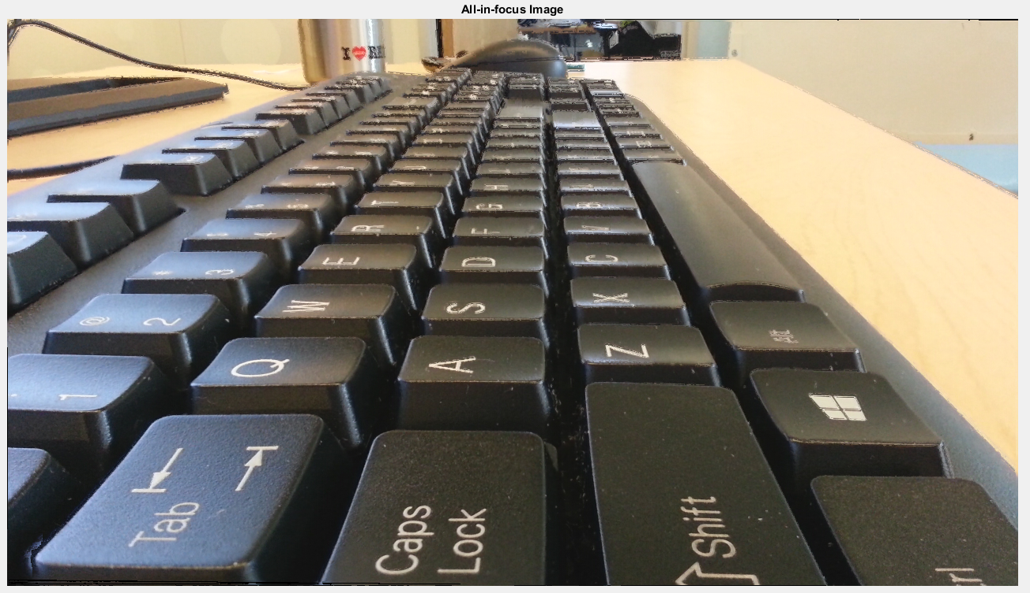

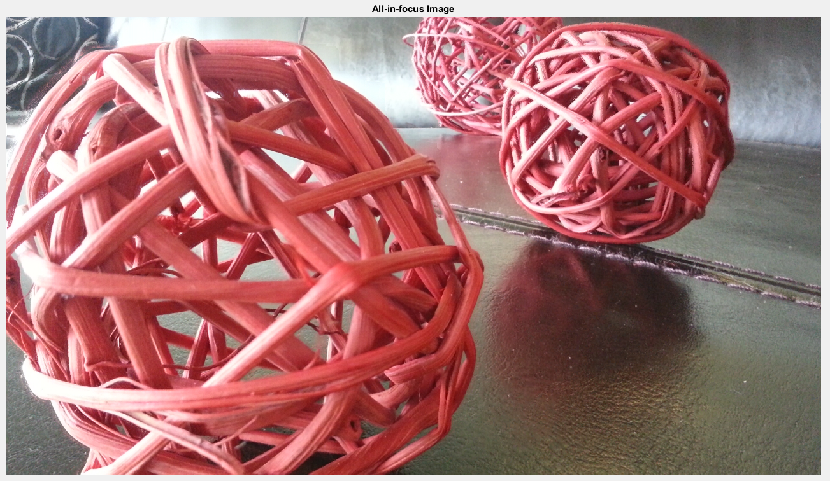

**Figure 4.1.** The all-in-focus image

1. **Step 5: Depth Refinement**

The all-in-focus image is the guidance for the weighted median filter [5]. The author of [5] provided the source code for the filter in [6].

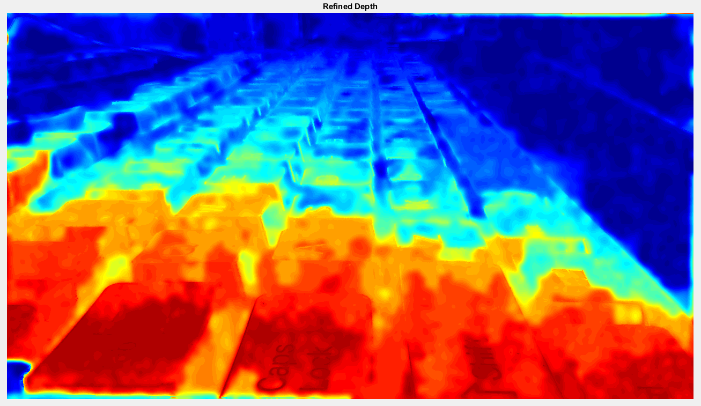

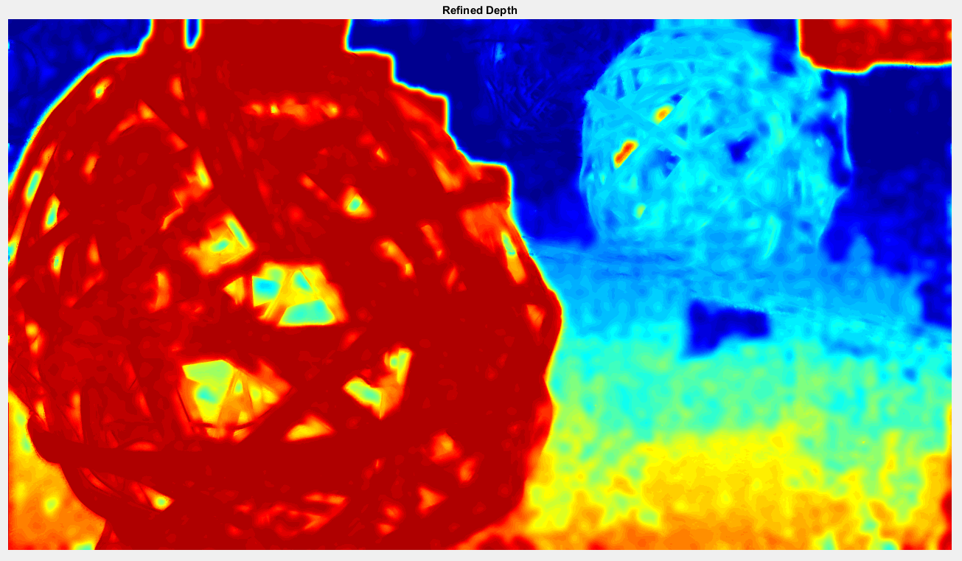

**Figure 5.1.** The depth refinement

# **Reference**

[1] Image Alignment Toolbox: A Matlab toolbox for image alignment and registration, <https://sites.google.com/site/imagealignment>

[2] Aamir Saeed Malik and Tae-Sun Choi, “A novel algorithm for estimation of depth map using image focus for 3D shape recovery in the presence of noise”, *Journal on Pattern Recognition*, volume 41, issue 7, July 2008.

[3] Yuri Boykov and Vladimir Kolmogorov, “An Experimental Comparison of Min-Cut/Max-Flow Algorithms for Energy Minimization in Vision”, *IEEE Transactions on Pattern Analysis and Machine Intelligence*, volume 26, issue 9, September 2004.

[4] Muli-label optimization, download source code gco-v3.0.zip, April 28th 2010, <https://vision.cs.uwaterloo.ca/code.html>

[5] Ziyang Ma, Kaiming He, Yichen Wei, Jian Sun and Enhua Wu, “Constant Time Weighted Median Filtering for Stereo Matching and Beyond”, IEEE International Conference on Computer Vision, December 2013, Australia.

[6] Source code for weighted median filter in [5], <http://kaiminghe.com>